CS 255 System Design Document

This template lays out all the different sections that you need to complete for Project Two. Each section has guidance to prompt your thinking. You will need to continually reference the interview transcript as you work to make sure that you are addressing your client’s needs. There is no required length for the final document. Instead the goal is to complete each section based on what your client’s needs are. Remove this note when you are finished, and replace all bracketed text with the relevant information.

UML Diagrams

UML Use Case Diagram
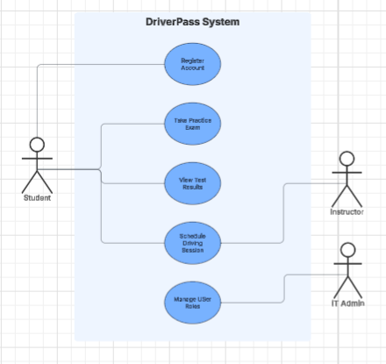

UML Activity Diagrams
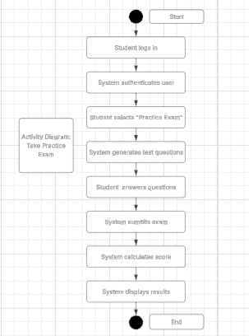
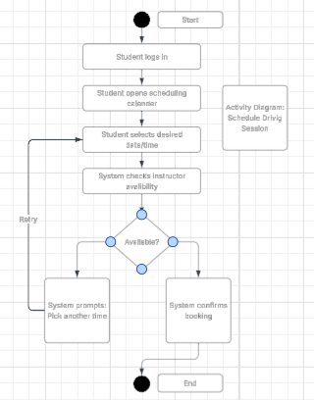

UML Sequence Diagram

UML Class Diagram
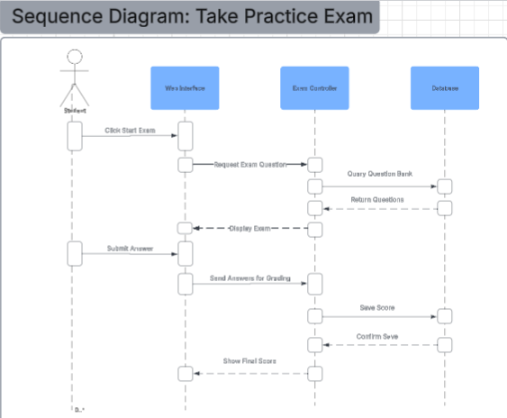

Technical Requirements

To make the DriverPass system a reality, we need to set up the right mix of hardware, software, and infrastructure. Instead of worrying about buying and maintaining expensive physical servers, we can host everything in the cloud using platforms like AWS or Microsoft Azure. This keeps the system flexible and ensures it stays online and runs smoothly even during busy study periods. For the software itself, the front-end—what the students and instructors see and click on—will be built using standard web technologies like HTML, CSS, and JavaScript so it looks great and works perfectly on any device. Behind the scenes, we will power the system with a reliable back-end language, such as Python or Java, connected to a secure database like MySQL. This ensures that all user accounts, exam questions, and scheduling details are organized and stored safely. As for hardware, it is completely hassle-free for DriverPass and its users; anyone can access the platform using a standard desktop, laptop, tablet, or smartphone, if they have a modern web browser and a reliable internet connection. Finally, our development team will use standard, modern coding tools and version control systems, like Git, to build, test, and launch the platform efficiently.

